Mercury Tours

**Overview:**

- Mercury tours is a web site for reserving flights, hotel rooms, car rentals, cruises, and vacation deals.

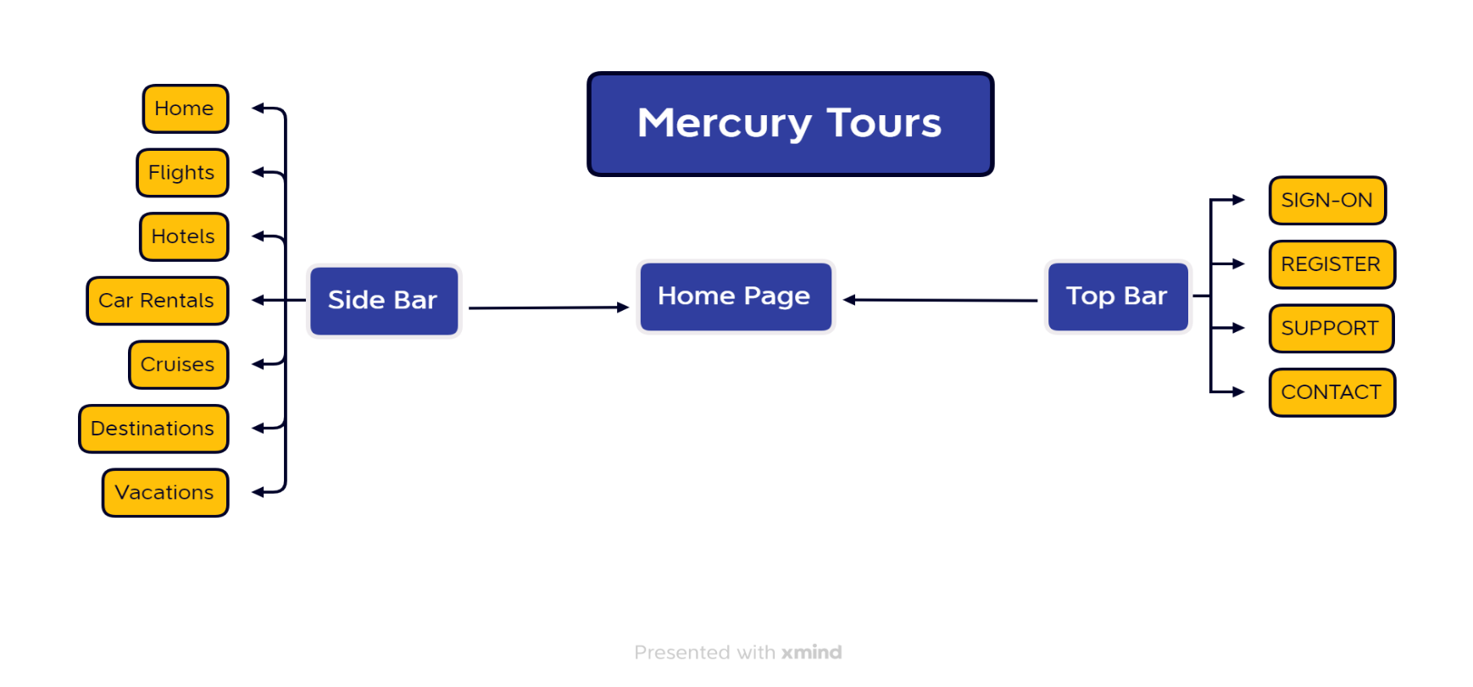

**Home Page:**

- It is the most important page of the web because it is the first page that a customer see therefore it should be user-friendly. It contains a logo, login form, date, links and images.

**Flights:**

- Flight finder is also one of the most important modules on the web page because it is used to search for flights therefore it should be also user-friendly. It contains drop down menus and radio buttons.

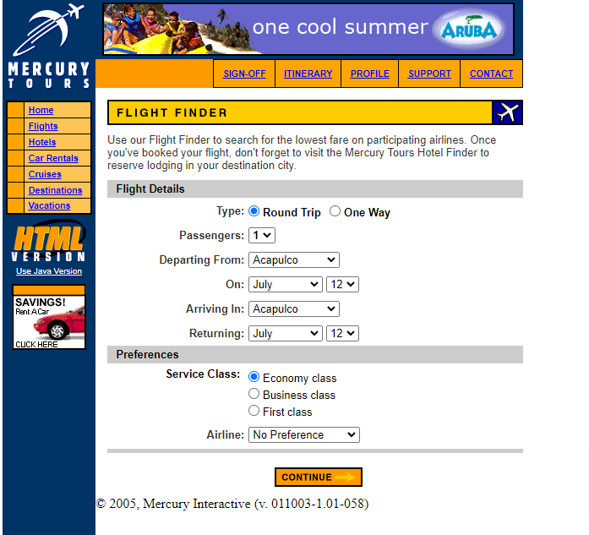

**Hotels, Car Rentals, Cruises, Destinations, Vacations, SUPPORT, CONTACT :**

- These sections of the web site are currently under construction!!!

- All sections should contain a warning message!

**SIGN-ON:**

- It serves to access the member-only areas of this site. It contains a login form and link to registration form.

**REGISTER:**

- It serves to create an account to the member-only area. It includes a registration form which is divided into the three parts and confirmation button.

